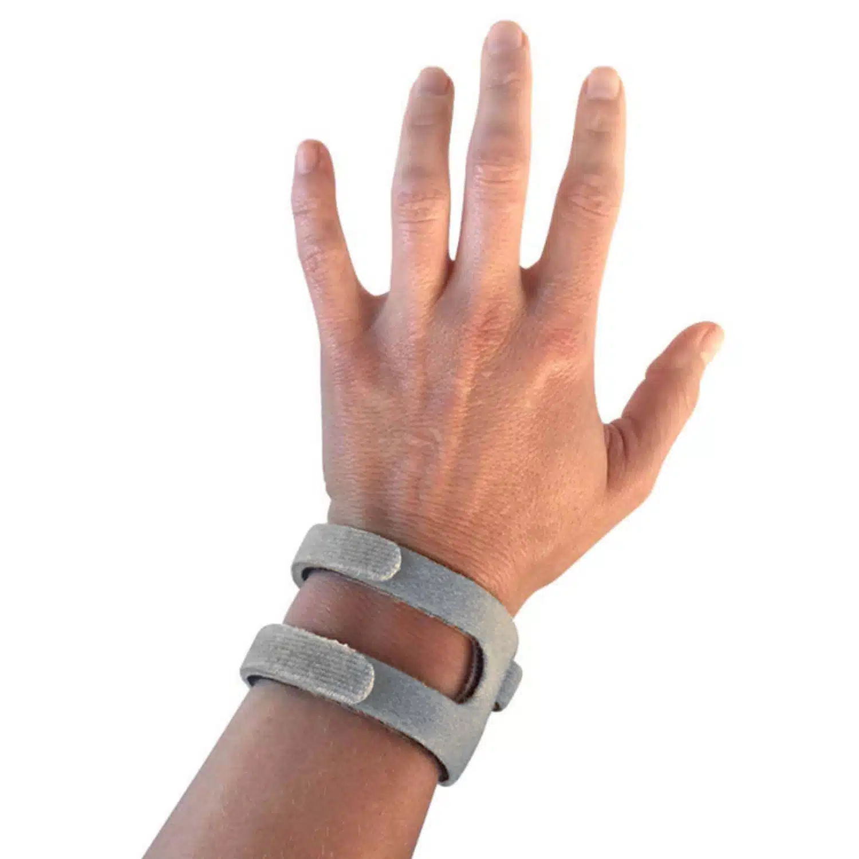
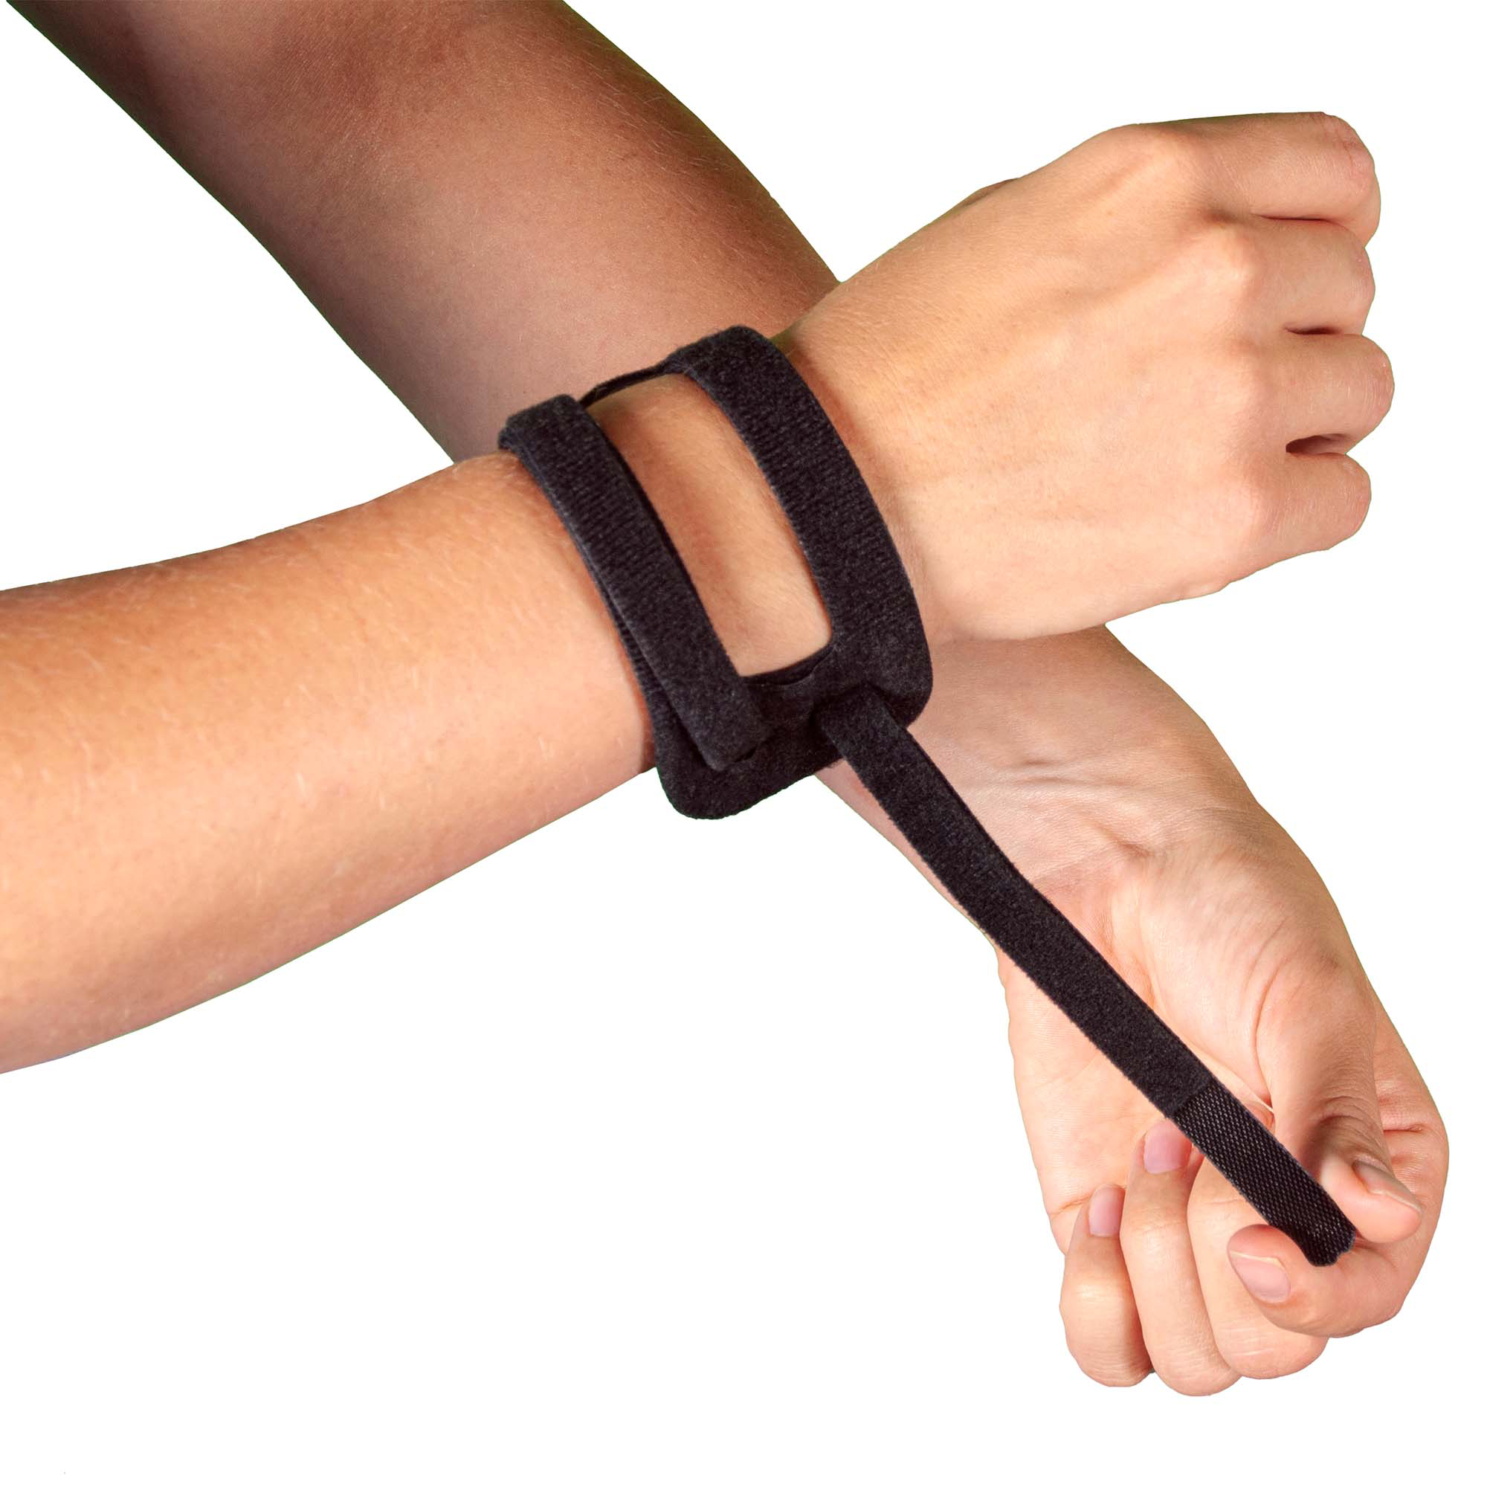
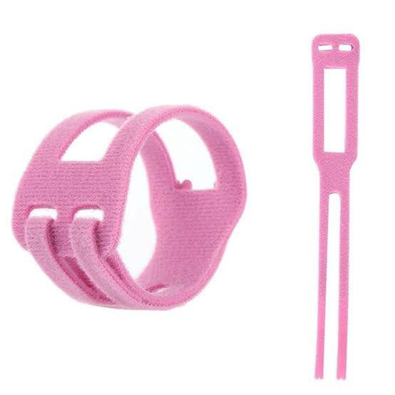
  - TFCC WRIST BRACE INSTRUCTIONS

Description:

Sore wrists can make everyday life so much harder than people realise. This TFCC wrist brace is designed to help support and stabilise the TFCC joint (a part of your wrist that helps with strength and control).

If you’ve been told you have a TFCC injury, or your wrist feels weak, wobbly, or painful on the pinky-side (ulnar side), this brace may be worth trialling to help reduce strain and add extra support during movement.

It can also be a supportive option for people living with arthritis, joint instability, chronic pain, or connective tissue conditions such as Ehlers-Danlos Syndrome (EDS).
Everyone’s body is different, so if you’re unsure what support is safest for you, it’s always a good idea to check in with a physiotherapist or medical professional for advice that fits your needs.

Great for:
🖐️ Supporting ulnar-sided wrist pain (pinky-side wrist pain)
🧷 Helping stabilise a TFCC injury
🦴 Joint weakness or wrist instability
🌀 Hypermobility support
🧬 Ehlers-Danlos Syndrome (EDS) and connective tissue conditions
🧓 Arthritis support and joint discomfort
🫶 Reducing strain during daily tasks
🧑‍🦽 Extra support on low-energy or flare-up days
🧑‍🍳 Cooking, prepping, and kitchen jobs
🧺 Household tasks like cleaning or folding
📦 Packing, lifting, or repetitive hand movements
🧑‍💻 Computer and desk work support
🎮 Gaming and controller use support
🧘 Gentle movement days where your wrist needs backup

Features:
🧩 Designed to support the TFCC joint
🖤 Wrap-style brace for targeted support
🪡 Soft material for comfortable wear
🪢 Adjustable Velcro fastening
🪶 Lightweight design
🧘‍♀️ Helps reduce strain during movement
🧊 Can be worn during flare-up days for extra support
🧤 Low-profile fit that can work under some sleeves
🔁 Easy to take on and off by yourself

Details:
Material: Polyester, Velcro
Size: 4.5cm (W) X 32cm (L)
Weight: 9 grams
Package Includes: 1x TFCC wrist stabilising brace
Age: 👤 Intended for adults. 🧒 If used by children or teens, use with supervision and guidance from a parent/caregiver and medical professional.
Note: Colour shades may vary.

How to Use:
👐 Wrap the brace around your wrist as shown in the product photos
🪢 Adjust the Velcro until it feels supportive and secure (not too tight)
🧊 Check your comfort and circulation (no numbness, tingling, or cold fingers)
🧑‍💻 Wear during tasks where your wrist needs extra stability and support
🩺 Follow your physio or medical professional’s advice for your specific needs

Care Instructions:
🧼 Hand wash gently with mild soap
💧 Rinse well after washing
🌬️ Air dry fully before wearing again
🚫 Do not bleach
🔥 Do not tumble dry

