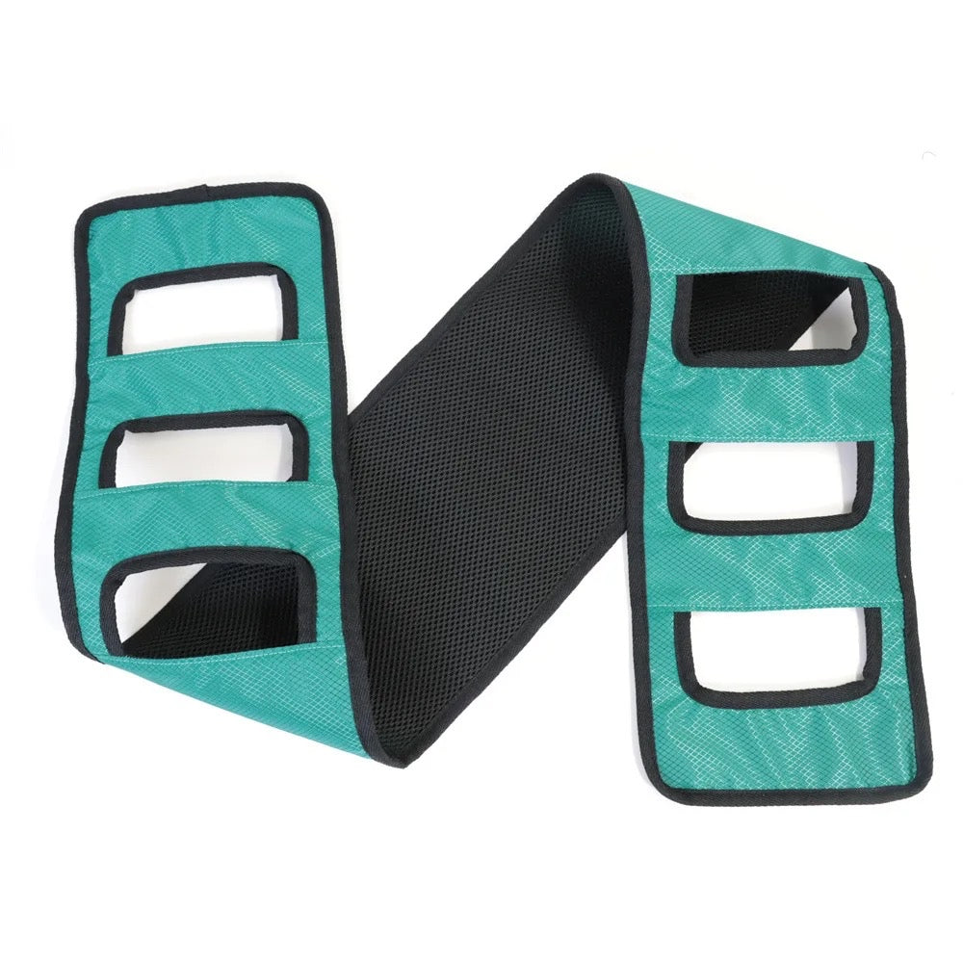
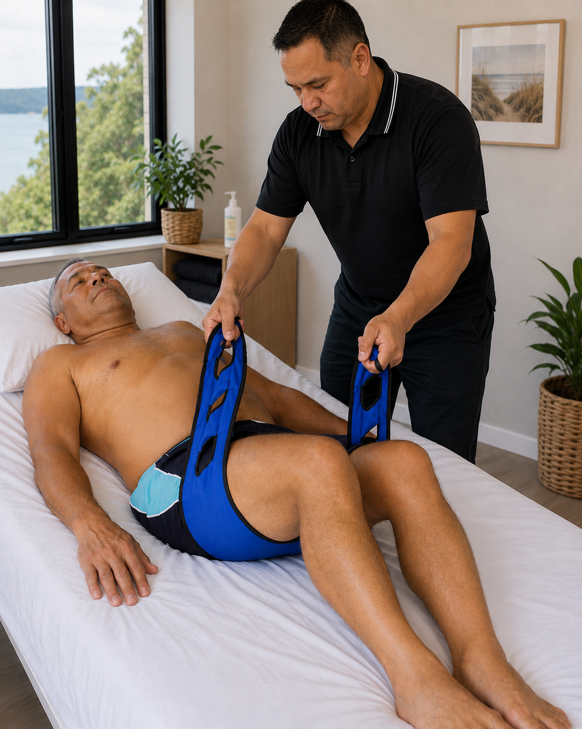
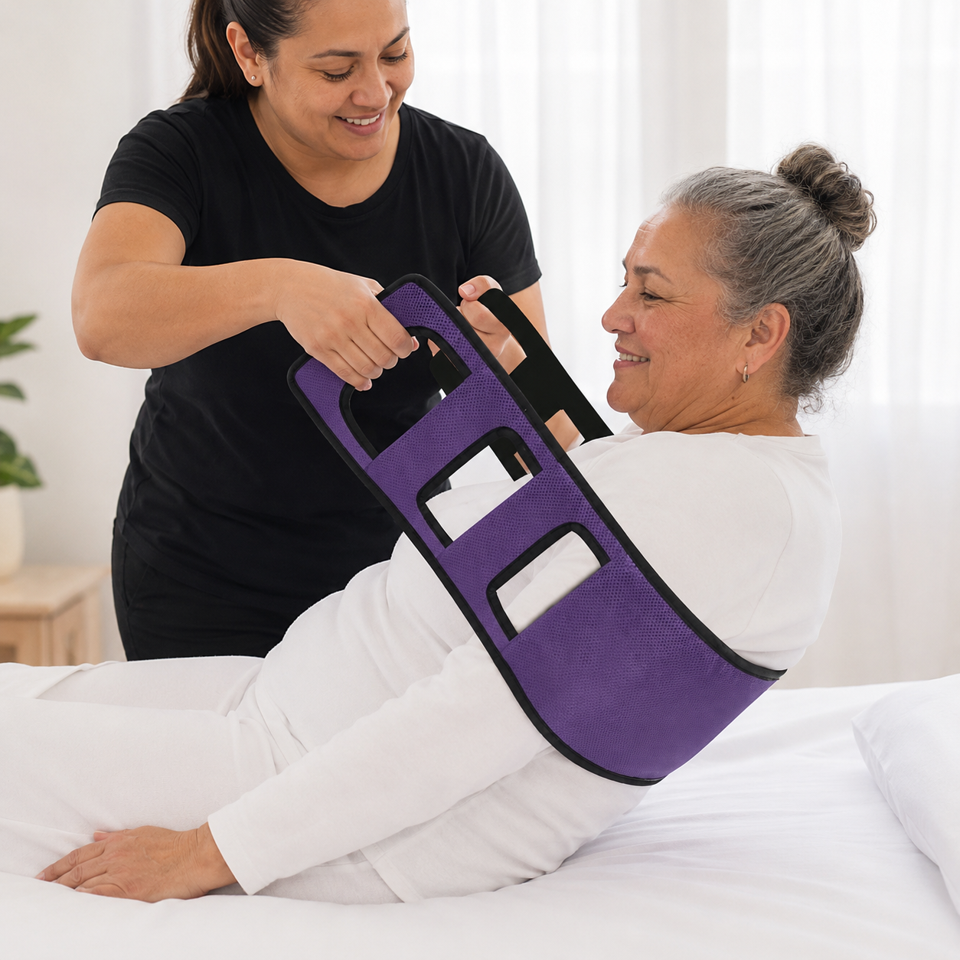
  - PATIENT TRANSFER ASSISTIVE AID

Description:

During critical illness, post-surgical recovery, palliative care, spinal recovery, and rehabilitation, this Patient Transfer Assistive Belt provides a secure and supportive way to assist transfers, repositioning, sitting support, and movement.
The wide padded centre creates a comfortable support base behind the body, while the multiple grip loops allow support from either side depending on the movement or level of assistance needed. From careful two-person support through to lighter stabilising support and more independent movement over time, this belt can adapt alongside changing strength, mobility, and rehabilitation needs.
It can also be looped onto a secure support point to create a grab assist for sitting up or repositioning more independently.

Great For:
🏥 Hospital and home recovery
🩺 Post-surgical support
🩻 Spinal recovery and rehabilitation
♿ Mobility support and transfers
🛏️ Bed repositioning and sitting support
🚽 Toilet and bathroom transfers
🤝 Two-person movement support
🧍 Standing support and stabilising movement
❤️ Critical illness support
🌿 Palliative illness support
🚐 Vehicle transfers and travel support
🪢 Creating a grab assist for more independent repositioning

Features:
✋ Multiple hand loops for flexible support positions
🖤 Wide padded centre for comfortable support behind the body
↔️ Allows support from either side during movement and transfers
🔄 Can adapt from higher support needs through to lighter stabilising support
🪢 Can be looped onto a secure support point as a grab assist
🧍 Supports assisted and more independent movement approaches
🪶 Lightweight and easy to store
🧼 Durable nylon construction
🚫 Designed to support movement and coordination, not full body lifting

Details:
Material: Nylon
Size: 120cm (L) x 12cm (W)
Weight: less than 50 grams
Package Contains: 1x Patient Transfer Assistive Sling
Age Guidance: Suitable for assisted movement, rehabilitation, repositioning, and transfer support with appropriate supervision. Not a toy.
How To Use:
🖤 Position the padded centre comfortably behind the lower back, waist, or hips
✋ Use the hand loops to provide secure support during transfers, repositioning, standing, or movement
↔️ One or more support people can assist from either side depending on the movement needed
🪢 Can also be looped onto a secure support point as a grab assist for sitting up or repositioning
💡 Designed to assist and guide movement, not lift a person’s full body weight

Care Instructions:
🧼 Wipe clean with a damp cloth
🌬️ Air dry fully before storing
🚫 Do not bleach
🪶 Store in a clean, dry place when not in use

Please Note:
⚠️ Designed to assist and support movement, repositioning, and transfers; not intended for full body lifting
⚠️ Always ensure any support point used for looping the belt is secure and stable
⚠️ Check regularly for signs of wear or damage before use

