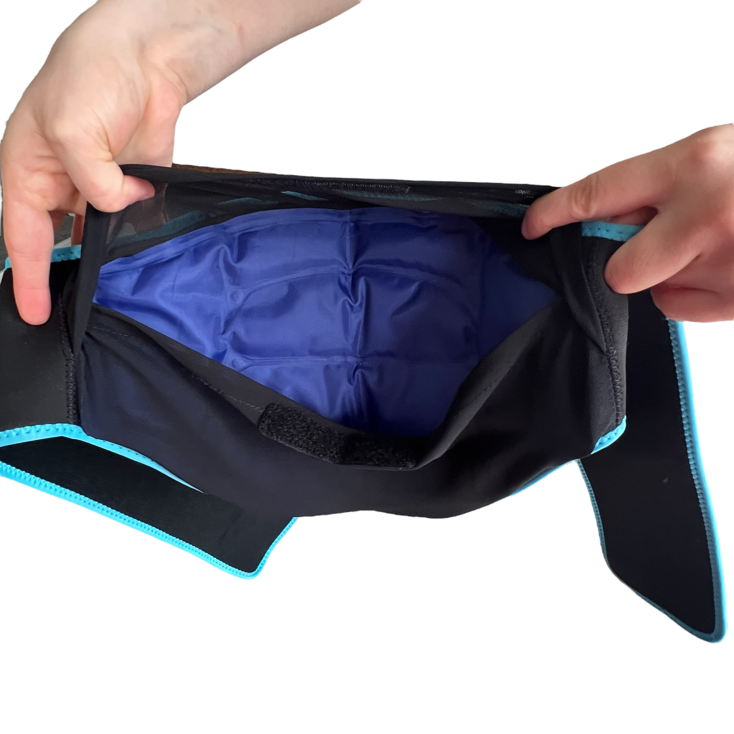
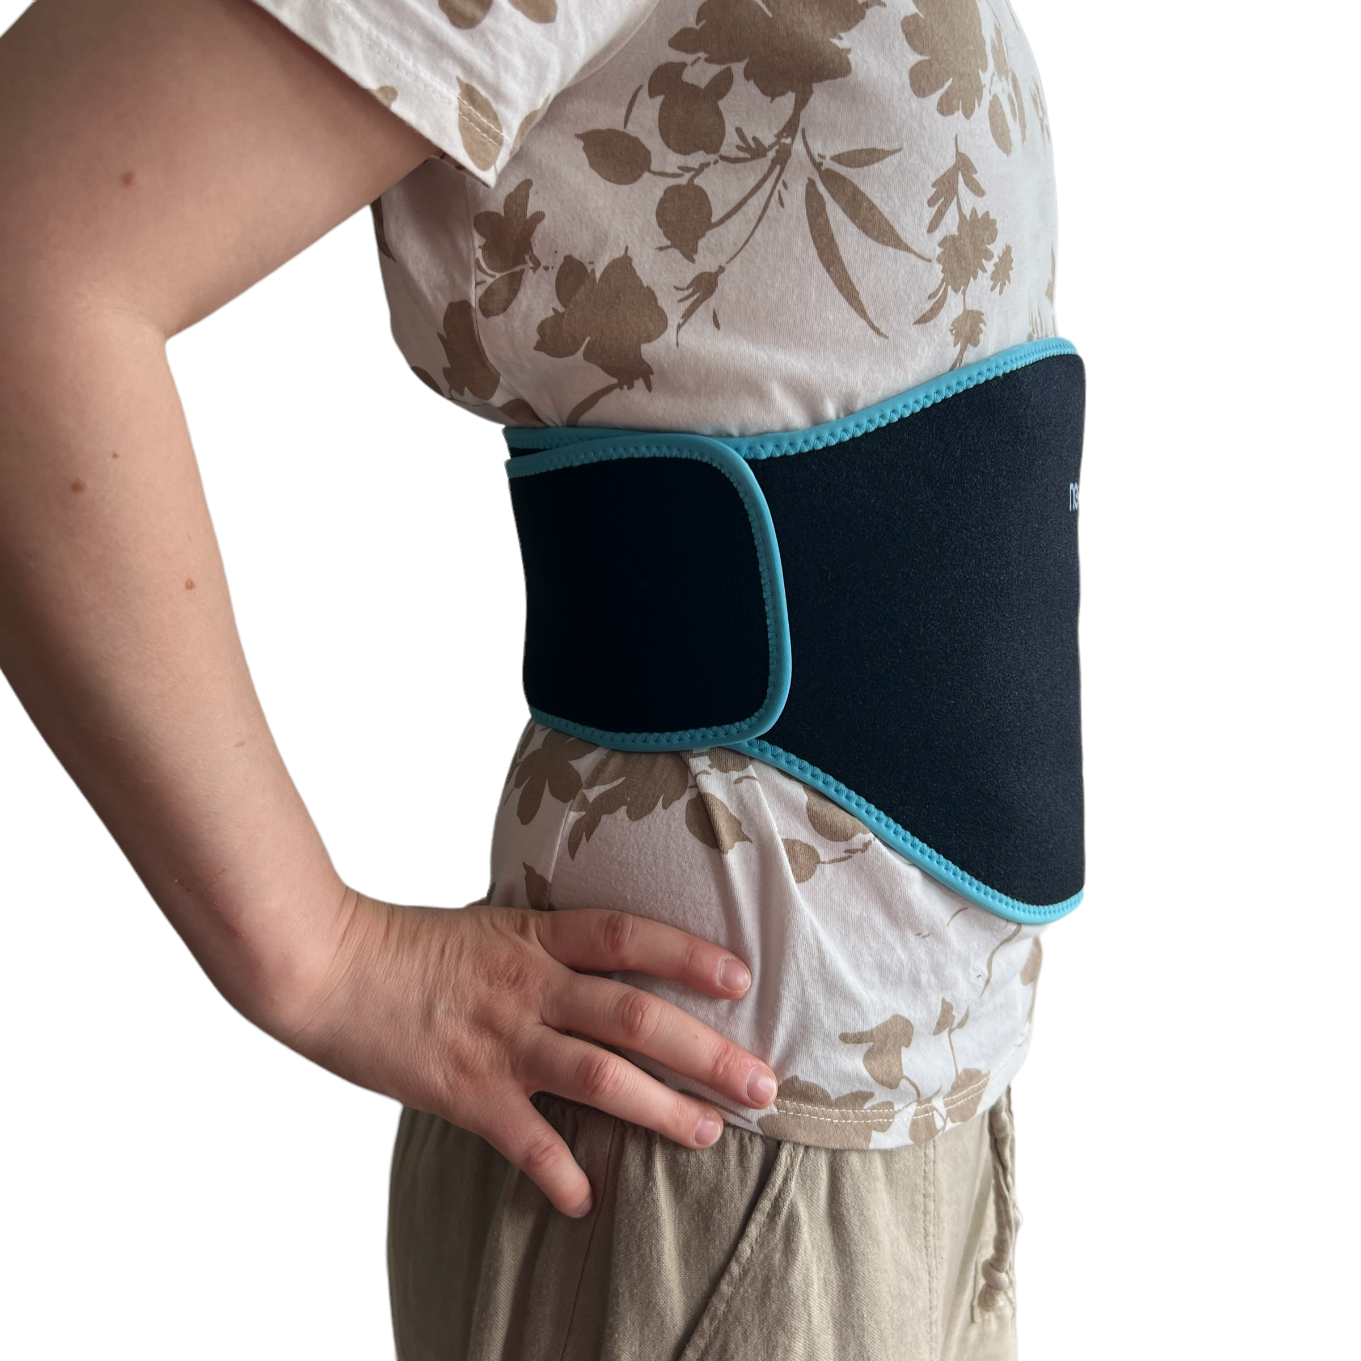
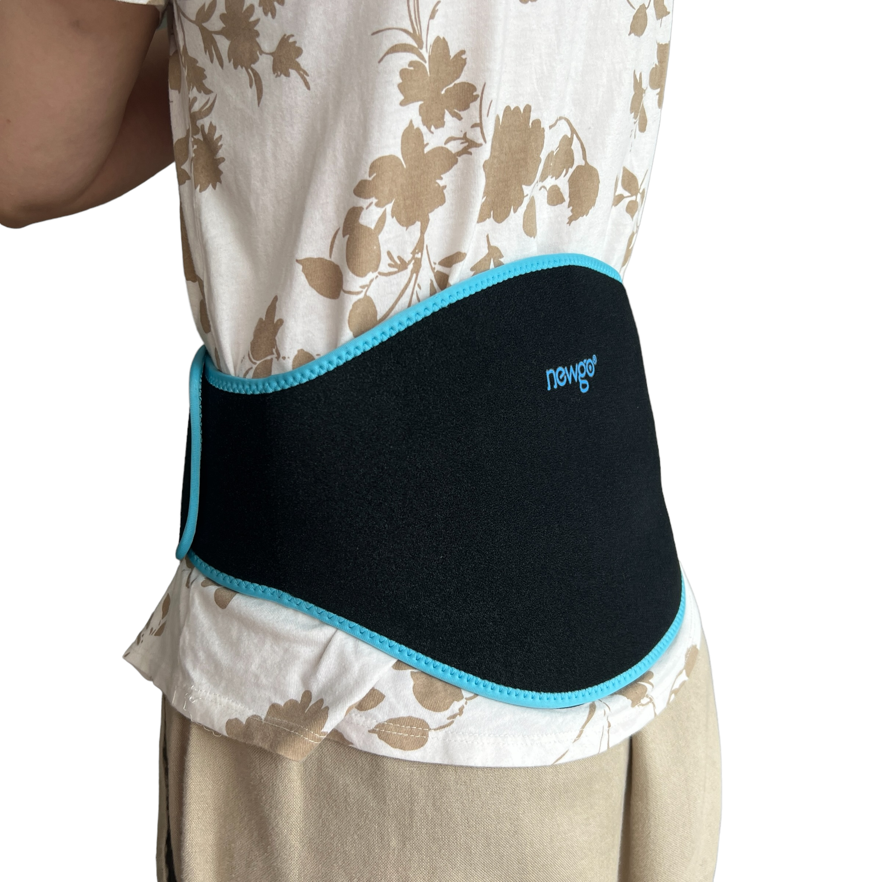
  - REUSABLE ICE PACK - BACK/STOMACH WRAP

Description:

Need relief that stays in place while you get on with your day? This hot and cold back wrap is designed to move with you, not slow you down.
Shaped to comfortably contour around your lower back (and flexible enough to reposition where needed), this wrap combines targeted support with the option of heat or cold therapy depending on what your body needs. Whether you are dealing with ongoing pain, a flare up, or just needing some comfort, it is built to sit securely and comfortably without constant adjusting.
The adjustable compression wrap lets you control the level of support and pressure, helping keep the gel packs in place while you are moving around, resting, or working. With two gel packs included, you can rotate them between uses or keep one hot and one cold ready to go.
It is a simple, practical way to bring relief into your day without having to stop everything.

Great for:
🔥 Muscle tension and tightness
❄️ Inflammation and swelling
🦴 Lower back pain and stiffness
⚡ Sciatica and nerve pain
🏃 Sports and incidental injuries
🩸 Menstrual cramps and abdominal discomfort
🌡 Managing overheating or fevers
💛 General comfort during flare ups or tough days

Features:
♻️ Reusable gel packs for both hot and cold use
🧵 Flexible wrap that contours to your body
🔒 Adjustable compression for a secure fit
🔁 Includes two gel packs for easy rotation
🧊 Suitable for fridge and freezer use
🔥 Microwave safe for heat therapy
🖐 Hands-free use so you can keep moving
Details:
Material: Neoprene, Gel Ice Packs
Size: 116cm (L) x 23cm (W)
Max fit: is probably around 106cm diameter
Weight: 520 grams
Package includes: 1x Reusable Waist Strap, 2x Gel Pack
Age Guidance: Suitable for adult use or with supervision

How to Use:
🧊 Place gel pack in freezer for at least 2 hours for cold therapy
🔥 Heat gel pack in microwave in 20 second intervals for warmth
🧵 Insert gel pack into the wrap pocket
🔒 Secure wrap around your body to your preferred compression level
🔁 Swap gel packs as needed to maintain temperature

Care Instructions:
🧼 Wipe wrap clean with a damp cloth
🌬 Air dry fully before reuse
🚫 Do not machine wash or tumble dry
☀ Store in a cool, dry place

Important Notes:
⚠️ Always check temperature before applying to skin
⚠️ Do not overheat gel packs
⚠️ Use a barrier layer if you have sensitive skin
⚠️ Not intended as a substitute for medical treatment

