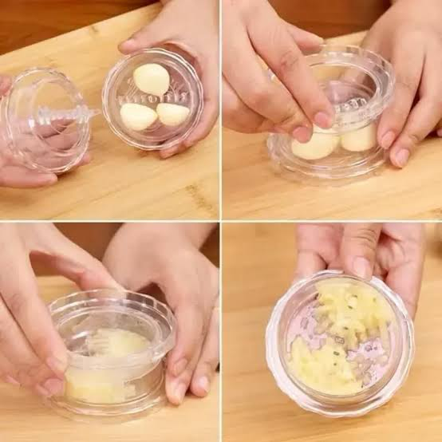
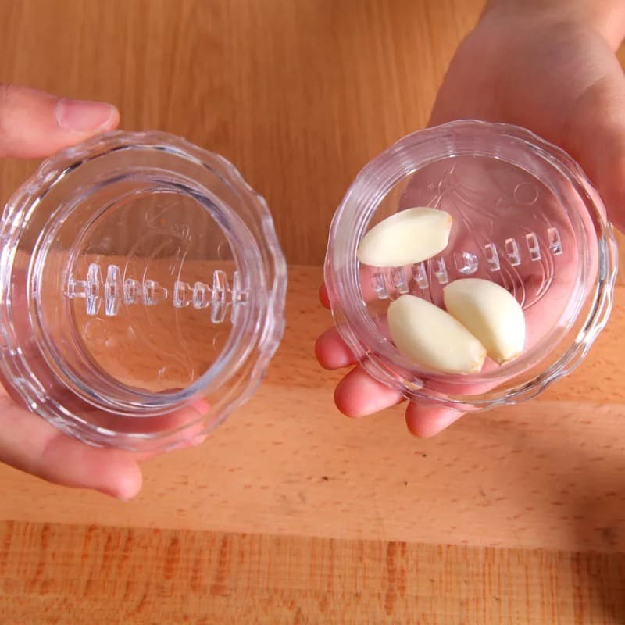
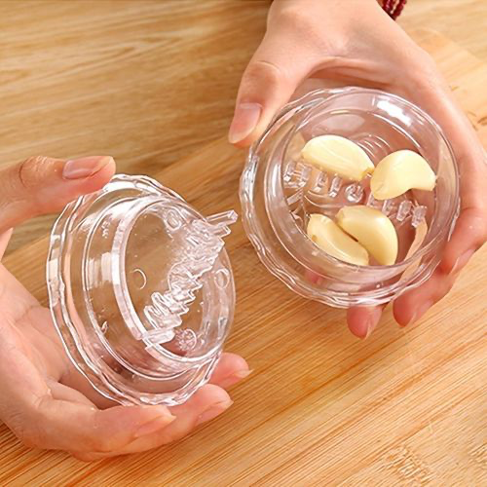
  - GARLIC CRUSHER

Description:
Crush garlic without reaching for a knife or traditional garlic press. This compact twist-style garlic crusher uses interlocking teeth to break down peeled garlic cloves as you rotate the two halves back and forth.

The rounded shape gives you a larger surface to hold than the handles of many garlic presses, while the twisting action removes the need for repeated squeezing. Once crushed, the garlic stays contained inside until you’re ready to add it to your cooking.

Great For:
🧄 Crushing and mincing peeled garlic
✋ Reduced grip strength or hand fatigue
💪 Arthritis, joint pain or hand stiffness
🔪 Reducing the need for knife work
🍳 Everyday cooking and meal prep
🏕️ Compact kitchens, caravans or camping

Features:
🔄 Twist back and forth to crush garlic
🧄 Interlocking teeth break down peeled cloves
🤲 Rounded shape provides a larger gripping surface
✨ Garlic stays contained inside while crushing
👀 Clear design lets you see the garlic as you work
🧼 Two-piece design separates for cleaning

Details:
Material: Plastic
Size: 7.5 cm diameter × 4 cm high
Weight: 100 grams approx
Package Contains: 1 × Garlic Crusher
Age Guidance: Suitable for adults and older children with appropriate supervision.

How To Use:
🧄 Peel the garlic cloves and remove the skin.
🔓 Twist the two halves of the crusher apart.
🥣 Place the peeled garlic into the bottom half.
🔄 Reattach the top and twist back and forth until the garlic reaches your preferred consistency.
🥄 Open the crusher and scoop out the garlic.
💧 If your recipe contains oil, stock or another suitable liquid, a small amount can be swirled through each half to help collect remaining garlic.

Care Instructions:
🧼 Separate both halves after use and wash thoroughly with warm soapy water.
🚿 Rinse around and between the crushing teeth to remove trapped garlic.
💨 Allow both halves to dry completely before putting the crusher back together.

