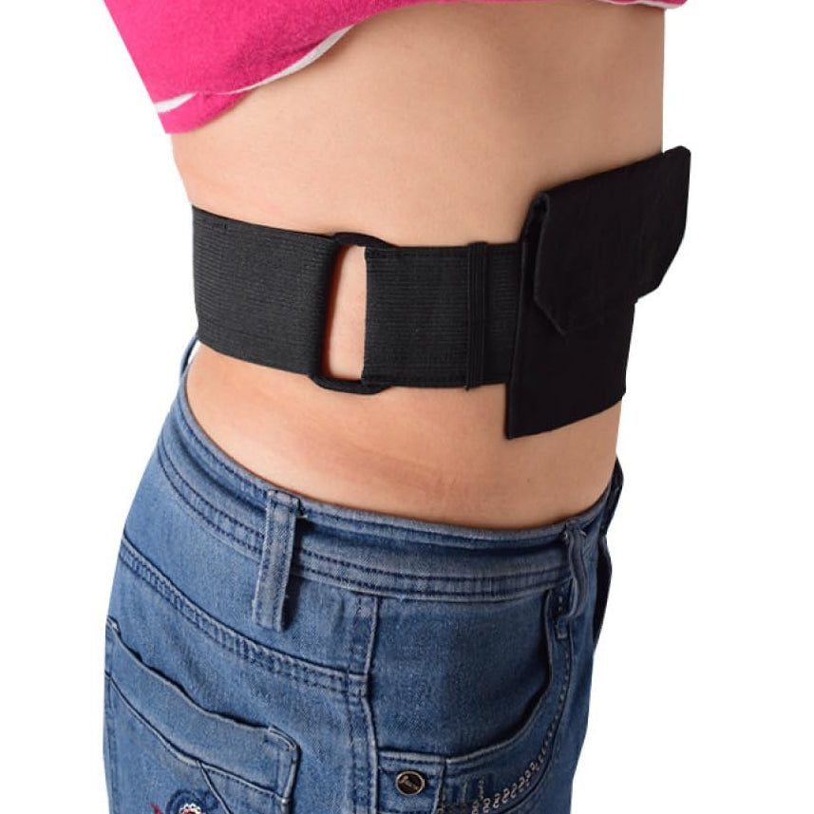
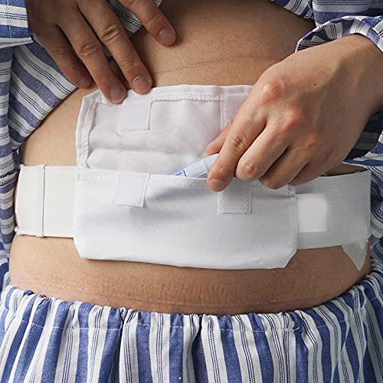
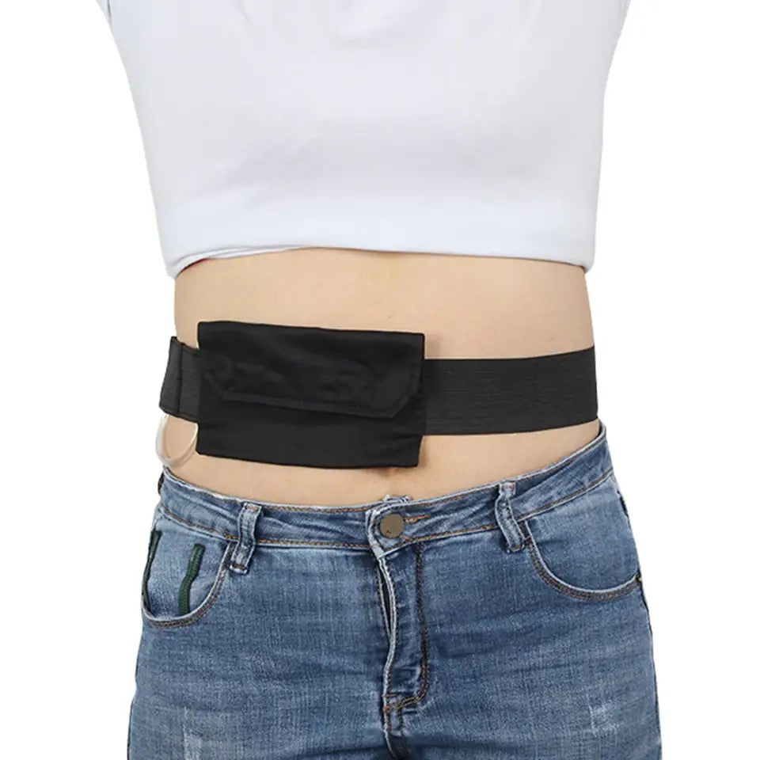
  - FEEDING TUBE + DIALYSIS BELT WITH POCKET

Description:
Need a safer, simpler way to keep feeding tubes or dialysis lines tucked away and close to your body?
This medical tubing securement belt is designed to help hold lines more securely in place while giving you more comfort and freedom to move through your day. Whether you are resting at home, heading out, or just wanting one less thing to worry about, this belt helps keep tubing more contained and supported.
Made with a soft stretch-style band and a front pouch, it offers a practical way to store and protect tubing while reducing pulling, snagging, or loose line movement. It is washable, reusable, and easy to wear under or over clothing depending on your preference.

Great for:
🩺 Supporting feeding tubes or peritoneal dialysis lines
🏡 Everyday wear at home or while out and about
🚶 Helping reduce line movement during daily activity
👕 Wearing under clothing for a more discreet option
🛏️ Keeping tubing tucked away while resting or sleeping
♿ supports managing ongoing medical tubing needs

Features:
🖤 Soft belt design for more comfortable day-to-day wear
👜 Front pocket helps hold tubing neatly and securely
🔒 Hook and loop closure for adjustable fit
🧼 Washable and reusable for ongoing use
🌿 Lightweight design that is easy to wear
🙌 Helps support confidence and convenience through the day

Details:
Material: Cotton, Nylon, Velcro
Size: Please see below…
Pocket: 15cm (W) x 9cm (H)
Belt: 96cm (L) x 5cm - 35-45.5cm (diameter)
Weight: 40 grams
Package Contains: 1x Tube Securement Belt
Age Guidance: Suitable and sized for teens and adults. Use for children with appropriate supervision and according to their medical needs. Not a toy

How to Use:
🧷 Wrap the belt around the waist or body area as needed
📏 Adjust the fit so it feels secure but comfortable
🩹 Place the tubing neatly into the front pouch
✅ Check that the line sits safely without pulling or kinking
👚 Wear under or over clothing depending on comfort and preference

Care Instructions:
🫧 Hand wash or gentle wash as needed
💨 Air dry fully before next use
🚫 Do not use harsh bleach or strong chemicals
🔍 Check regularly for wear and tear before use

Safety Information:
⚠️ This product is a support aid only and should not replace clinical advice or securement guidance from your medical team
⚠️ Always ensure tubing is not kinked, compressed, or pulled when wearing
⚠️ Check fit regularly to avoid discomfort or pressure on sensitive areas
⚠️ Stop use if irritation, discomfort, or skin issues occur
⚠️ Seek medical guidance if unsure whether this product is suitable for your specific line or tubing setup

